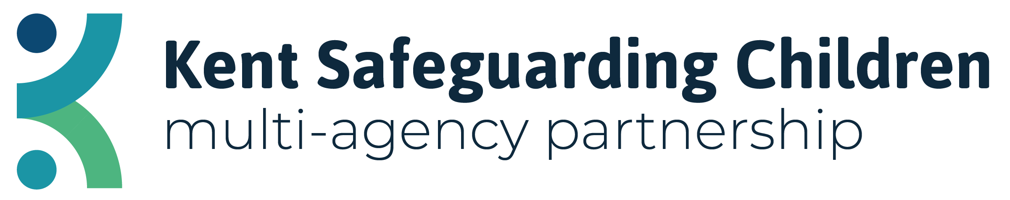

Learning from Cases of Adolescent Neglect

In 2021, the Practice Review Group of the Kent Safeguarding Children Multi-Agency Partnership agreed that an analysis of learning from cases of adolescent neglect should be undertaken following cases where this is a common theme.

Similar findings detailed below can also be found in a Serious Case Review published by Thurrock Safeguarding Children Board in 2016; this report is available at the end of this document.

Key Learning Themes Identified

Adolescent Neglect, Communication Between Agencies and the Child’s Voice

Both cases featured concerns regarding adolescent neglect where the young people involved were displaying outward signs of not caring for themselves such as personal hygiene nor eating and drinking.

Professionals will have differing viewpoints, according to their role, focus and viewpoint and this can have an impact on a multi-agency response to cases of adolescent neglect.

Additionally, neglect becomes more complex as a child ages and develops as this will link to greater independence from carers and developing autonomy over their decision making, therefore, achieving a “working consensus about what constitutes adolescent neglect becomes an essential preliminary to practice. This is particularly important where several agencies are involved with improving the well-being of young people.”.

In our local case, while there was good communication between agencies, there were differing opinions on the causality of these behaviours which may have led to a delay in an appropriate safeguarding response for the child. Furthermore, there appears to have been a focus on creating change within the young person as oppose to changing the environment around them.

There appears to have been assumptions made in both cases about the child’s choice to self-neglect and professionals are encouraged to consider whether this was indeed a choice or a result of learned or indirectly encouraged behaviours by the parents/guardians.

Reflective Questions for Professionals

- Are you using appropriate respectful challenge when working with other agencies to understand their concerns regarding adolescent neglect?
- Have you, as multi-agency professionals, discussed what reasons you feel contribute to the child self-neglecting?
- Does the age of the child impact on whether professionals view their behaviour as self-neglecting?
- Are safeguarding concerns for the child being given enough importance when there are additional factors regarding mental health needs that may be viewed as more immediate?

Impact of the Coronavirus and National Lockdown on Young People

In our local case, the child appears to have been functioning fairly well prior to the national lockdown but returned to school very unwell and requiring significant intervention from health services.

The child in question was not permitted to attend school in September 2020, however, this in turn had a detrimental impact on the young person who had been looking forward to returning in September following the national lockdown and school holidays. This may have further contributed to issues in their mental wellbeing.

In a survey conducted by Young Minds in January 2021, respondents mostly spoke of loneliness and isolation, concerns about school, college or university work and a breakdown in routine. Therefore, it is anticipated many young people are likely to have experienced social isolation due to the pandemic and professionals should be mindful of how this may impact on mental wellbeing.

Reflective Questions for Professionals

- Has the voice of the child been obtained in regard to the impact of the pandemic on their mental wellbeing?
- Are there services or other forms of support in the child’s local area that they can be signposted to outside the remit of statutory services such as local charities and youth hubs?

SCR Megan – Thurrock Safeguarding Children Multi-Agency Partnership

Hicks, L. and Stein, M., 2000. Adolescent neglect: guide for professionals. [online] GOV.UK. Available at: <https://www.gov.uk/government/publications/neglect-matters-a-multi-agency-guide-for-professionals-working-together-on-behalf-of-teenagers> [Accessed 9 March 2021].
YoungMinds. 2021. Coronavirus Report: Impact on Young People with Mental Health Needs. [online] Available at: <https://youngminds.org.uk/about-us/reports/coronavirus-impact-on-young-people-with-mental-health-needs/#covid-19-january-2021-survey> [Accessed 12 March 2021].

