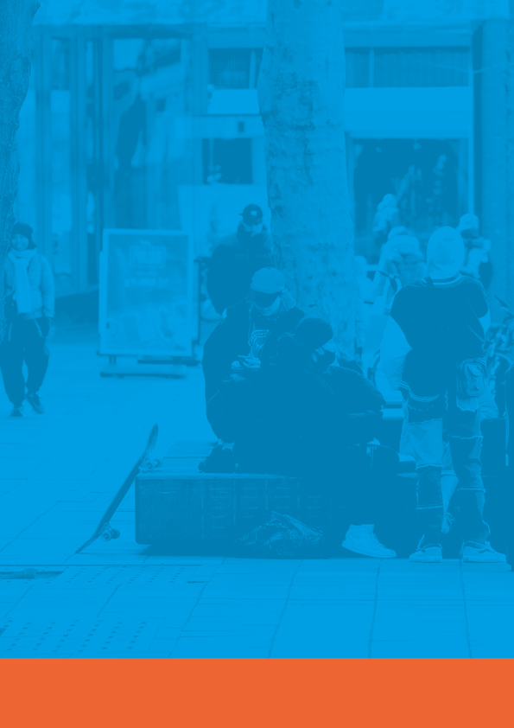

Kent and Medway Gangs Strategy

2020-2024

Contents

Introduction 3

Executive Summary 4

Safeguarding 5

National picture 5

Local picture 9

Achievements of previous strategy 9

Critical Success Factors 10

Governance 11

Objectives 11

Gangs and County Lines Strategy Action Plan 12

Appendix 1 16

Appendix Two 18

Foreword
Gangs, and the violence that arises as a result of gang activity, can have a devastating impact on both the individuals involved and the surrounding communities. Though only a small number of our young people are involved in gangs – fewer than 1% of Kent and Medway’s children and young people come into contact with the Criminal Justice System in total – these individuals can have a disproportionately negative influence on wider society as a result of their anti-social behaviour and crime.
Since the first Kent and Medway Gangs Strategy was created in 2018, we have seen significant improvements in how agencies work together to tackle gangs. We have become better at sharing information and there has been an increase in the resources available to tackle gangs. The Police and Crime Commissioner’s Violence Reduction Challenge, the work of Kent Police and Community Safety Partnerships to prioritise gangs, and the Home Office Funded Violence Reduction Unit have all contributed to how we reduce the harm from gangs.
However, gangs have also evolved and still pose a threat to individuals and communities. We have seen a greater focus on using social media to drive the supply of drugs within the County, and adaptations in how gangs operate in our communities. Gangs continue to identify, groom and exploit vulnerable children and adults, and work is still required to protect individuals from harm.
This document sets out our approach to building on the progress, and how we will tackle gang crime and ensure community safety It outlines where we are now and where we want to be in the future in order to better lead, plan, commission and deliver services across our partnership.
The activities we are undertaking aim to disrupt and enforce as well as support gang members and those affected by gangs. This document does not replace the individual strategies and action plans each agency has in place to deal with gangs operating in Kent and Medway or local area Community Safety Partnership plans. Rather, this strategy sits over our individual agency strategies, providing a clear ‘statement of intent’ in relation to our partnership work in this arena and a collective focus to address gangs together through an agreed set of objectives, outcomes and measures. This strategy also allows us to establish a common language and shared understanding of what a gang is and what it does across our partnership – enabling us to work across our agency boundaries more effectively to tackle the issues arising.
As a result of local profiling, we know that most young people involved in gangs in Kent and Medway are aged between 15 and 25. This strategy therefore focuses on this cohort. However, we recognise that gangs can target vulnerable people of any age and put them at risk of serious harm, and we take this into account in both our strategic approach and operational practice. We recognise that young people involved in gangs can be subject to multiple other associated risks, such as trafficking, going missing, sexual exploitation and even radicalisation. We work tirelessly to ensure that these associated risks are identified early and that we provide the right services to support young people in the best way to keep them safe and to promote their wellbeing.
This strategy provides us with a clear framework around which we can focus our resources and energy to have the greatest impact, with an emphasis on prevention and diversion alongside enforcement. Perhaps most importantly, we want to stop young people from becoming engaged with gang activity at the earliest stage and to make it easier for them to exit gangs when they are already involved. Only by working together can we achieve these goals and this document underscores our commitment to doing so

Michael Hill, OBE, Cabinet Member for Community and Regulatory Services, Strategic and Corporate Services, Kent County Council

Councillor Adrian Gulvin, Portfolio Holder for Resources and chair of the Medway Community Safety Partnership, Medway Council

Executive Summary
This Gangs Strategy is informed by what has worked since the first Gangs Strategy was agreed in 2018. The vision of the strategy remains the same as that outlined in the previous version which is to:
Protect and prevent young people from becoming involved with Gangs; to tackle gang-related harm and youth violence; and to pursue effective enforcement action to deal with those embroiled in gang activities.
The strategy outlines the key objectives that partners have identified as being critical to success. It is informed by national publications which provide a framework for collaboration on how to achieve long term change that creates safer spaces and communities, and which protects individuals from the harm associated with Gangs or County Lines.

Priorities
We will work together collaboratively, across our local agency partnerships, to achieve the key priorities that we have identified as central to delivering our vision:
- Have a clear understanding of the level of Gang and County Line activity across Kent & Medway along with the associated criminal exploitation. All agencies will know how to report concerns and what their role is in supporting those affected by Gangs or County Lines.
- Ensure that the needs of individuals at risk of criminal exploitation are met swiftly and in a way which prevents exploitation from occurring. Safeguarding of children and vulnerable adults from Gangs and County Lines will be at the heart of the work of services.
- Improve the collaboration around enforcement to sustain the success and ensure that there is a coordinated approach across agencies whenever enforcement is required.
- Equip communities with the skills and resources to create safer spaces. The public perception on the impact of County Lines will report that communities feel safer.
- Develop and share a strengths-based approach to support and enforcement informed by research on what works. The work will allow all professionals, communities and families to understand the risks of criminal exploitation or County Lines, and to know what action they can take to either respond or ask for support.
- Ensure that service users and those with lived experience are involved in the design and delivery of interventions aimed at tackling Gang or County Line harm.

There is a focus on growing and sharing the knowledge around Gangs and County Lines with as wide an audience as possible, creating opportunities for diversion and for people to be equipped with the confidence either to offer support or to ask for help. Communities are unlikely to change and to become safer without being given the skills, resources and assistance that will allow them to change.
The picture around Gangs and County Lines has changed significantly since 2018 when the first strategy was published; it is likely that there will be further changes in how Gangs and County Lines operate within the County and the strategy will need to be reviewed on a regular basis to be confident that the issues it aims to address are still relevant.
The strategy outlines the vision and objectives and has an action plan for how the objectives will be achieved. Taken together these provide a framework for collaboration which will tackle Gangs and County Lines whenever they emerge and will increase the safety of individuals and communities.

Safeguarding
The Gangs strategy is focussed on the need for organisations and services to safeguard children and vulnerable adults from harm. Involvement with Gangs or County Lines exposes individuals to risks of serious harm as well as potentially bringing them into the criminal justice system, and any organisation will need to ensure that safeguarding sits at the heart of any response to Gang or County Line concerns. This may be achieved through providing support and assistance to individuals or families where risks have been identified, the sharing of information with others or through effective disruption and enforcement against those seeking to cause harm to others.
Gangs and County Lines are known to target and groom children and vulnerable adults. Individuals of interest to Gangs may be in situations which result in the neglect of their basic needs, live in an unsafe environment, have poor attendance at school or in the care of the Local Authority. These situations can lead to individuals being at increased risk of exploitation including criminal exploitation as they may be drawn into the gang or County Line through offers of financial or emotional support, or through the sense of belonging that is initially attractive. Vulnerable children and young people at risk of criminal exploitation by Gangs or County Lines are also at risk of a whole range of aligned abuse due to gang affiliation, from emotional and psychological maltreatment to sexual abuse and debt bondage. Certain groups of young people are at more risk of specific types of abuse. For example, professionals have particular concerns about the risks posed to vulnerable gang-associated girls and young women, who can be subject to specific forms of sexual and physical abuse in gang situations and are often a ‘hidden’ cohort.
Another risk relates to the safeguarding of vulnerable adults. We know that particularly vulnerable individuals such as single parents, those with learning difficulties, the elderly, those with mental health problems or drug dependencies may be more at risk of being coerced and exploited by Gangs. ‘Cuckooing’, where Gangs use the homes of vulnerable adults as a base from which to deal or harbour drugs, is an ongoing concern; these individuals may also be groomed and manipulated by gang members to sell drugs on the gang’s behalf. Vulnerable adults may further be coerced into becoming drug ‘runners.’
It is also known that those involved in Gangs or County Lines are often most at risk of being harmed by others and are likely to have experienced trauma as a child. Agencies will need to be mindful that individuals cannot be seen either as ‘victim’ or ‘perpetrator’ and may need to consider that any individual could be both.

National picture
In recent years there has been an increasing concern around the linked issues of Gangs and County Lines operating across the Country, and the twin concerns of serious violence and criminal exploitation linked with these issues. In 2018 the Home Office published the Serious Violence Strategy which aims to break the cycle of violence associated with Gangs and County Lines. It lays out four key themes:
- tackling county lines and misuse of drugs,
- early intervention and prevention,
- supporting communities and partnerships,
- an effective law enforcement and criminal justice response.
The strategy raises particular concerns about the supply of Opiates and Crack Cocaine and notes that, while overall crime continues to fall, homicide, knife crime and gun crime have risen since 2014 across virtually all police force areas in England and Wales. Robbery has also risen sharply since 2016. These increases have been accompanied by a shift towards younger victims and perpetrators. Most of the violence is also male on male. (Serious Violence Strategy, Home Office, April 2018, p7) Approximately half the rise in robbery and knife/gun crime is felt to be due to improvements in police recording. For the remainder, drug-related cases are considered to be an important driver.
The Violence and Vulnerability report (February 2021, Crest Advisory) found that rises in serious violence are linked to a shift towards younger people, that victims of serious violence are getting younger and a growing number of young people are becoming involved in the supply of drugs. Children at risk of serious violence are not evenly spread across the Country and the report highlights links between living in vulnerable communities (those most affected by violence or deprivation) and the risk of becoming a victim of serious violence or becoming involved in gang related activity.
There has been an increasing focus on identifying those vulnerable to criminal exploitation: exclusion from school has been identified as a particular risk factor (Both sides of the coin. The Police and National Crime Agency’s response to vulnerable people in ‘county lines’ drug offending p21) along with living in deprived communities or those with high levels of crime, parental neglect or substance misuse, or being a ‘looked after’ child. These indicators are well known to services as being indicators of concern. Risks are acknowledged around creating a County Lines organisational silo and it is recommended that vulnerabilities are understood, tracked and responded to using a wide understanding of vulnerability rather than focussing on a single issue.
Support available to adults, either those involved in County Lines or who are vulnerable to exploitation, reduces when compared to that available for children. There have been fewer national reports on services available to adults at risk of County Lines exploitation compared to those considering the risks that children face, and there is less information available on proposed solution to the challenges identified.
The picture around County Lines is one that is changing and evolving, as groups and individuals adapt their methods in response to the increase in enforcement aimed at tackling County Line drug supply. The London Rescue and Recovery Service has identified gaps in agency understanding about how social media is used to target individuals and state that, ‘Social media continues to hold great influence over young people and this continues to be capitalised on by exploiters in order to groom them onto county lines. Further to this, the wide reach of the online space means that peer association can be exploited even further, and that grooming is not just dictated by locality.’ (Rescue and Recovery. Year 2. Sep 2020, p6). There are known gaps around the impact that County Lines has on women and girls and their involvement both as victims and as those involved in the running of County Lines.
In October 2019 the whole-system multi-agency approach to serious violence prevention guidance was published by Public Health England. This outlines that, ‘Serious violence cannot be tackled in isolation. It must be addressed through prevention strategies that address the multiple risk factors that cause and perpetuate violence and promote the protective factors that mitigate against the perpetration and victimisation of violence. (A Whole System Multi-Agency Approach to Violence Prevention, Public Health England 2019, p8).
From a public health perspective preventing children and young people from becoming perpetrators or victims of violence is a key consideration to avoid escalating levels of harm to both children and wider society. It identifies key risk factors as being centred around:
- the individual
- relationships individuals have with others
- the community
- societal factors

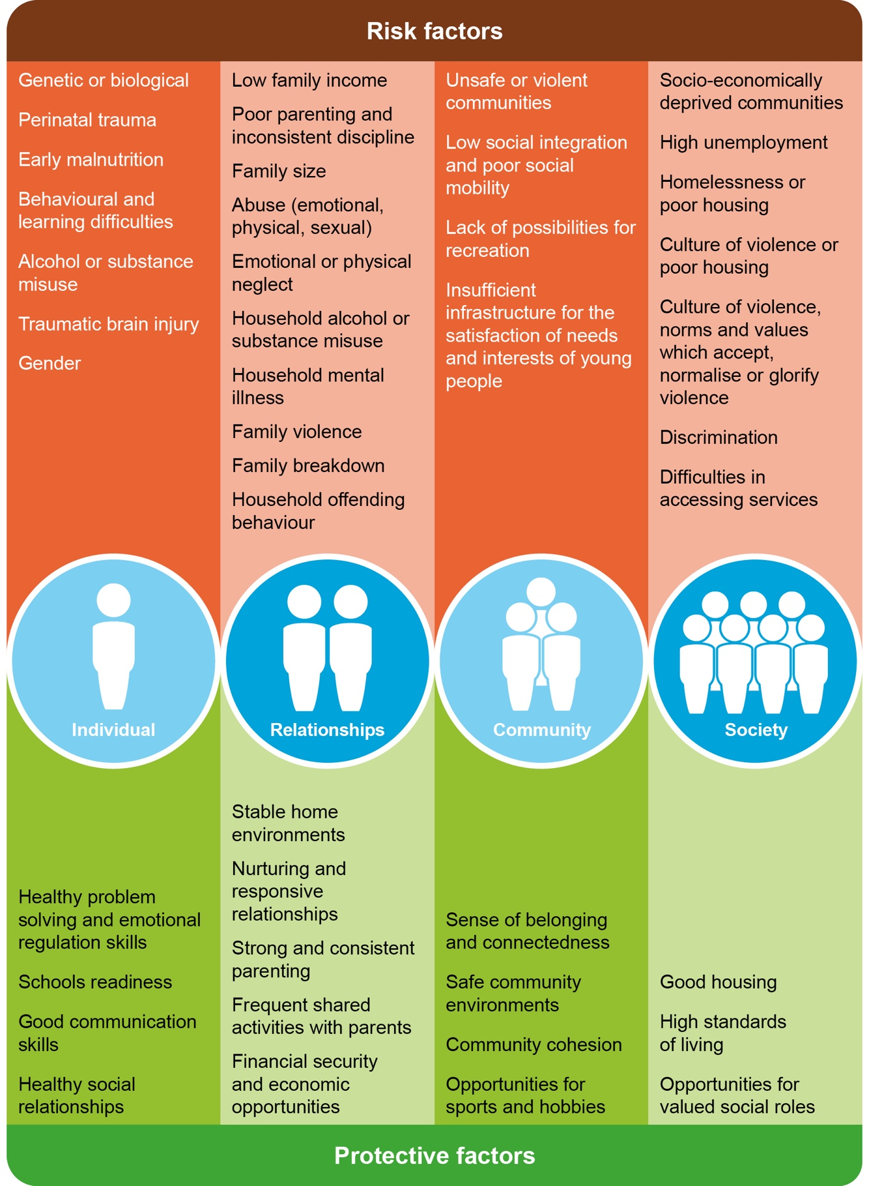

Figure 1 – Risk factors which increase the likelihood of violence and protective factors which mitigate against perpetration or victimisation of violence (11-16) (A Whole System Multi-Agency Approach to Violence Prevention, Public Health England 2019)

As part of the work Public Health England created a place-based multi-agency approach to serious violence prevention for England in designed to inform the delivery of a co-ordinated approach to tackle and reduce serious violence. It sets out some principles which local partners can adopt to work together to prevent violence.
These principles are called the 5Cs because there are 5 component parts which are:
- collaboration
- co-production
- co-operation in data and intelligence sharing
- counter-narrative development
- community consensus, which is central to the approach
These can be used as a guide to address the specific needs of a local population reflecting local geographies, operating systems, existing partnerships and community assets, resources and most importantly need. Variation and innovation in the implementation of the approach in different localities therefore is expected but wherever the component parts of the approach are adopted it will apply the principles of public health to prevent and tackle serious violence.
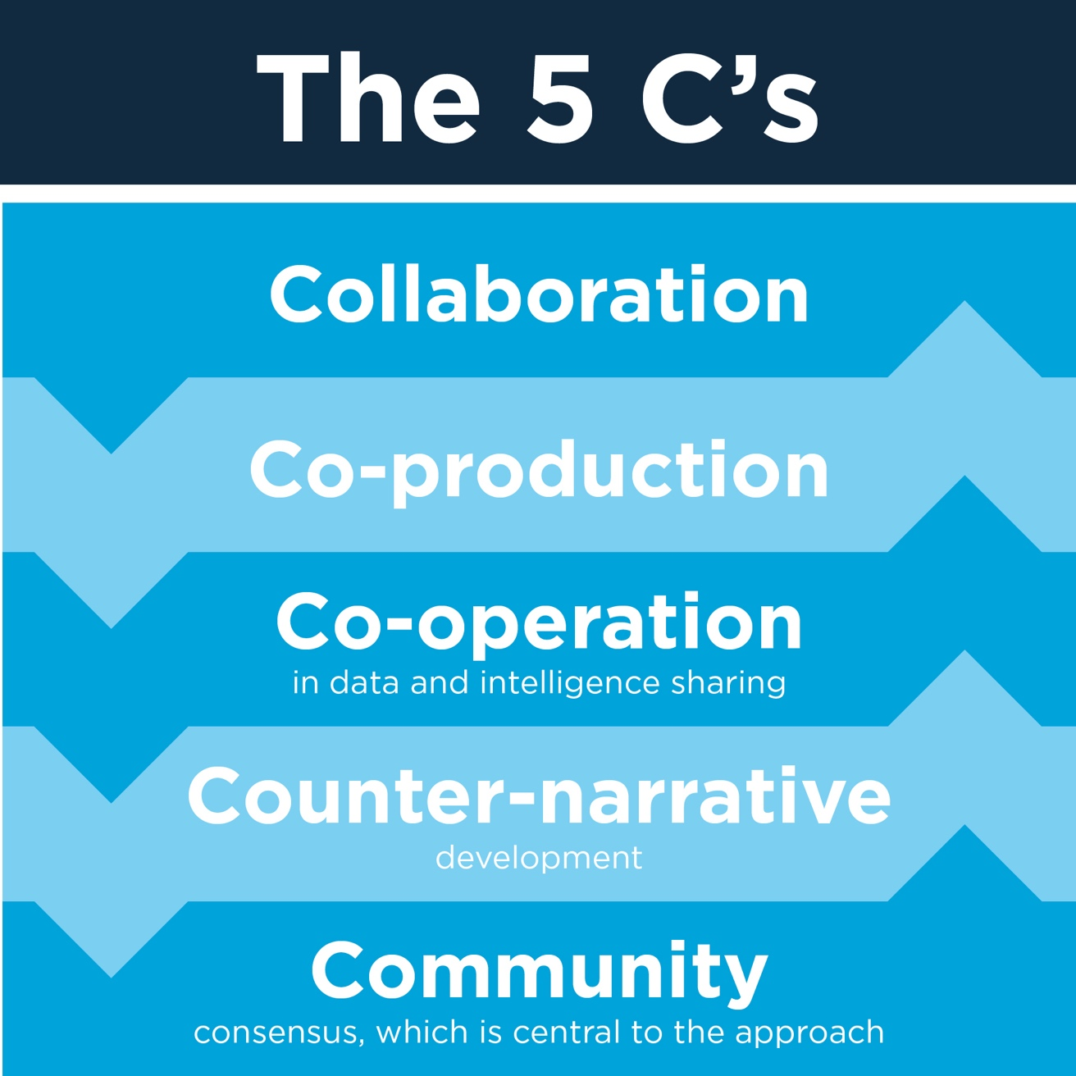
Figure 2. The 5Cs: a place-based multi-agency to serious violence prevention.

Local picture

Kent & Medway Gangs Strategy
2018-2021 Objectives
Create a shared understanding of Gangs across the local partnership and a common language and approach to our work with Gangs and groups.
Strengthen our early intervention and preventative work to stop young people becoming involved with Gangs early on, and to dissuade those on the cusp of becoming drawn into gang activity – primarily through improvements in the sharing of information.
Protect vulnerable individuals who may be targeted by Gangs and who are vulnerable to criminal behaviour.
Develop support pathways to help young people out of Gangs and violent behaviours.
Drive forwards effective enforcement and offender management to deal with those individuals involved in Gangs who refuse to reform.
Create and manage public spaces in a way that discourages gang congregation and associated antisocial behaviours.

The County has been successful in tackling both violence and organised crime since 2018. Challenges remain around the levels of violence which cause injury but there has been a downward trend in the last three years, and organised crime continues to be disrupted. The emerging challenge for the County is that of County Lines drug as Kent, along with other counties, has seen an increase in the numbers of County Lines supplying drugs, and in particular Class A drugs (heroin, cocaine and crack cocaine), to residents of Kent.
The county areas closest to London continue to have the highest recorded links to London County Lines networks, and those along the south coast are most affected. The London Rescue and Response service identifies that Kent is the Police Force ranked 5th against the numbers of individuals involved in County Lines activity from London and Kent saw an increase in activity when compared with the previous year (September 2020 compared to September 2019).
Kent Police analysis identifies that there have been successes in reducing the number of County Lines in the County: In April 2020 there were 72 scored County Lines active which, through Police enforcement and partner collaboration, had reduced to 52 in February 2021 and 49 in March 2021. The communities most affected by County Lines are in Medway, Thanet and Folkestone but County Lines were identified in every district in the County between October 2019 and September 2020 with the exception of Tonbridge and Malling.
The lines originate primarily from London and the most common London boroughs affecting Kent in this period were Southwark, Greenwich and Hackney. In March 2021 the three most common London boroughs where lines originated from were Croydon, Greenwich and Bromley. The flexible nature of County Line drug supply is illustrated by the shifts in places of origin.
Public Health are currently updating their drugs needs assessment and in this include an estimated 6,000 current opiate or crack cocaine users, although these figures have a high confidence range, and it is difficult to quantify the exact number of drug users.

Achievements of previous strategy
The strategy set out six key objectives and a review carried out between October 2020 and February 2021 found that there had been progress made against each of them.
The review highlighted the significant improvements made around information sharing and collaboration to protect children through a multi-agency approach driven at district level. This approach has become embedded within practice and is a platform that has helped to drive approaches that protect vulnerable children.
The County has been able to use funding from the Police and Crime Commissioner, the Home Office and the Ministry of Housing, Communities and Local Government, as well as resources from statutory agencies, to develop and enhance the support available to individuals vulnerable to criminal exploitation. Two additional multi-agency Task Forces in Medway and Maidstone have been established to build on the success of the Thanet Task Force.
Kent Police are collaborating with partners to share intelligence and to provide analysis that helps a greater understanding of County Lines activity. The Police have established the Chief Constable’s Crime Squad and within this are specialist Gangs and County Lines teams which have been able to disrupt County Lines as and when they emerge.
The establishing of District Contextual Safeguarding Meetings by the Local Authorities has supported a significant improvement in district or borough based collaboration amongst agencies. These meetings have provided a framework for a coordinated response that has focussed on creating safer places as well as the support available to adolescents of concern.
The review also highlighted areas where there is a need to improve; the multi-agency response to protecting vulnerable adults at risk of criminal exploitation from County Lines is less well defined, the resources available to protect vulnerable adults are fewer when compared to those available to children, and the understanding and use of powers to manage public spaces are not used consistently across the County.
There is also a need to share learning and understanding of what works across a wider network of professionals, communities and individuals so that the awareness of the issues and the ability to respond is embedded across the County. The successes of the Task Forces have highlighted the need for local responses which are rooted in and shaped by the communities affected by County Lines. This remains a challenge for those who commission services at district, borough and County levels.

Critical Success Factors

By 2024 we will:
- Have a clear understanding of the level of Gang and County Line activity across Kent & Medway along with the associated criminal exploitation. All agencies will know how to report concerns and what their role is in supporting those affected by Gangs or County Lines.
- Ensure that the needs of individuals at risk of criminal exploitation are met swiftly and in a way which prevents exploitation from occurring. This will ensure that individuals are effectively safeguarded and protected from harm.
- Improve the collaboration around enforcement to sustain the success and ensure that there is a coordinated approach across agencies whenever enforcement is required.
- Equip communities with the skills and resources to create safer spaces. The public perception of the impact of County Lines will report that communities feel safer.
- Develop and share a strengths-based approach to support and enforcement informed by research on what works. The work will allow all professionals, communities and families to understand the risks of criminal exploitation or County Lines, and to know what action they can take to either respond or ask for support.

Performance will be measured by:
- A reduction in the number of County Lines that operate within the County by 2024 compared with 2021.
- An increase in the community perception of the safety of their town or area by 2024 compared with 2021.
- Young people and young adults reporting that they feel safer or are confident in the support available to them that is linked with Gangs or County Lines by 2024 compared with 2021.

Governance
The governance of the strategy will be the responsibility of the Kent & Medway Community Safety Partnership Executive Boards. The two Boards will be responsible for setting and agreeing the strategy, monitoring progress and agreeing any changes to the aims or priorities of the strategy.
The Violence Reduction Unit will provide strategic oversight of the outcomes arising from the multi-agency responses outlined in the action plan. The Safeguarding Children Boards and Adult Safeguarding Partnership will require an awareness of the strategy, including the aims and objectives, delivery and impact, and the agency responsible for coordinating individual actions within the overall plan. The strategy will support a Public Health informed approach to tackling Gangs, County Lines and related criminal exploitation for those aged under 25 across the County.

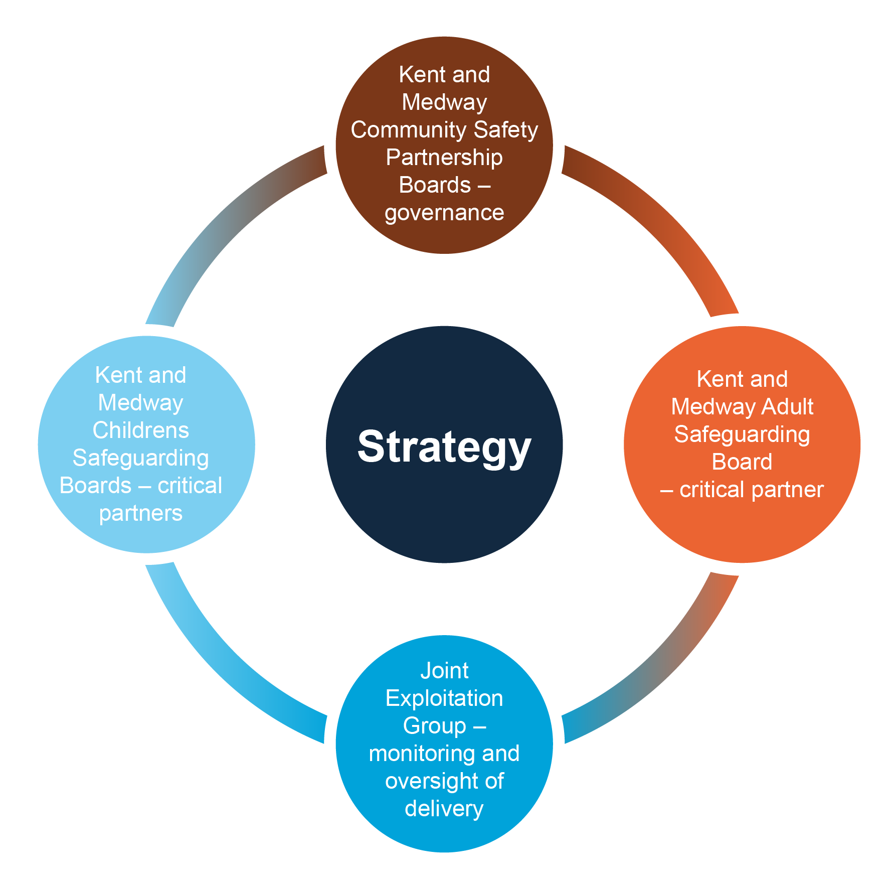

Figure 3 – Governance and oversight of the Gangs Strategy 2021-2024
The Kent and Medway Violence Reduction Unit (VRU) will be responsible for coordinating the delivery of the action plan and monitoring the impact and success of the strategy. The VRU will report to the Kent and Medway Joint Exploitation Group on a bi-annual basis and provide an update to the group on the delivery and outcomes arising from the implementation of the strategy.

Objectives
In order to achieve the stated aims and priorities of the strategy, four key objectives have been established, and an action plan developed that demonstrates how the objectives will be met. The objectives are:
- Understand the picture
- Collaboration and information sharing
- Support individuals
- Community Consensus and Support
The strategy and action plan will be informed by a clear narrative that promotes a strengths-based approach to creating safety for individuals, families and communities. This builds on the work from the Glasgow VRU and the emerging findings from evaluating approaches and programmes to tackle violence.

Gangs and County Lines Strategy Action Plan

Understand the picture
There are opportunities to develop an evidence-based approach to Gangs and County lines using existing infrastructure. An evidence-based approach will allow us to understand what works and what is less effective. Analysis and mapping will inform our strategic approach to tackling gang and county line activity as well as informing preventative approaches.
What | Who | By when | What will we see
Shared understanding – A single coordinated public awareness campaign that defines the problem in the County, and which provides signposting to additional guidance or to services that offer support, should be established. | Kent Police | Deadlines for achieving agreed actions will be agreed with lead agencies | Parents, communities and professionals will understand and know how to respond to or seek help on concerns around County Lines or criminal exploitation.
Shared understanding and co-production – Work with individuals and communities affected by Gangs or County Lines to ensure interventions and responses to County Lines and criminal exploitation are informed by and developed with service users and communities. | Kent Police County Lines Independent Advisory Group |  | Interventions and support are designed in collaboration with people with ‘lived experience’ of Gangs or County Lines.
Shared Understanding – Evaluate and publish findings of existing initiatives commissioned to tackle Gangs or County Lines (for example the impact of East Kent approach to cuckooing or services commissioned by the VRU or OPCC) | Multi-agency (including OPCC, VRU, CSP) |  | A body of evidence on what approaches have significant impact will be available.
Shared Understanding – A shared resource of evidence and ‘lessons learned’ to inform multi-agency working, based on what we know works will be established and hosted on a virtual platform that is accessible to all partners and communities. | Kent and Medway Safeguarding Children Partnership |  | A body of evidence on what approaches have significant impact will be available.
Analysis & Mapping – Develop and share strategic and operational analysis on County Lines and criminal exploitation which identify patterns and trends, hotspots of activity, individuals involved in County Lines or those at risk of criminal exploitation. | Kent and Medway Violence Reduction Unit |  | Professionals and appropriate partners will use analysis to inform responses to Gangs or County Lines.
Analysis and Mapping – Update the Strategic Needs Assessment (SNA) on drug use in the County. Use the updated SNA to focus on support and treatment for users of Class A drugs to reduce the demand. | Kent Public Health  Medway Public Health |  | Statutory agencies will understand where demand for illegal drugs is situated and will be able to develop support for those using illegal drugs.
Analysis & Mapping – Develop and share analysis on exploitation that considers the overlaps between criminal, sexual and other forms of exploitation. | Kent Police - Protecting Vulnerable People |  | Partners will have a greater understanding of how different types of exploitation occur and interact.

Analysis & Mapping. Commission analysis to consider the role and impact of Gangs or County Lines in Kent and Medway on  - girls and women,  - the Black, Asian and Minority Ethnic communities  - Children in the care of the Local Authority including those supported by Leaving Care services  - Children with Special Educational Needs | Kent and Medway Violence Reduction Unit  Kent County Council  Medway Council  Kent Police |  | Partners will understand how specific groups or cohorts are affected by Gangs or County Lines activity.
Analysis & Mapping. Commission analysis on the use of social media as a tool used by Gangs or County Lines to groom or exploit children and vulnerable adults. | Kent Police - Protecting Vulnerable People |  | Partners will understand how Social Media is used to exploit or groom vulnerable individuals.
Analysis & Mapping. Commission analysis on sexual exploitation within Gangs or County Lines culture, how it can be an intrinsic element of grooming and recruitment and ultimately used as debt bondage. | Kent Police - Protecting Vulnerable People |  | Partners will understand how and to what extent sexual exploitation and violence are features of Gangs and County lines.

Collaboration and information Sharing
Whilst pathways exist for information sharing, these need to be developed to ensure gateways are clear, and that there is a consistent approach to recording and sharing information to ensure latent risks are identified early. Collaboration between statutory services, other critical partners, the voluntary sector and communities will underpin any response to Gangs or County Lines.
What | Who | By when | What will we see
A quarterly briefing will be produced which outlines the patterns and trends around Gangs and County Lines in the County. The briefing will be available to professionals, communities and individuals. | Kent and Medway Violence Reduction Unit |  | Improved understanding of how communities are being impacted by County Lines and any emerging areas of concern.
Improve the use of eIntel as a portal for intelligence dissemination through promoting the eIntel form and the development of a feedback loop so that those who report are informed of any actions or response. | Kent Police - Protecting Vulnerable People |  | Information about Gangs and County Lines will be shared in a timely manner with Kent Police. Those sharing information will understand the response from Kent Police once information has been shared.
Provide regular updates on Gangs & County Lines at district partnership meetings. Provide information on what activity is taking place and to identify possible reasons as to why it is occurring in specific locations. | Kent and Medway Violence Reduction Unit  Kent Police Gangs Teams |  | Professionals and appropriate partners will use analysis to inform responses to Gangs or County Lines.
Develop a robust, pan-Kent multi-agency shared data set on County Lines and the associated violence, which all relevant agencies can access, to inform planning and collaborative activities. | Kent and Medway Violence Reduction Unit |  | Professionals and appropriate partners will use analysis to inform responses to Gangs or County Lines.

Improve the sharing of relevant intelligence with prisons, schools and other critical partners. | Kent Police (supported by Local Authorities & the National Probation Service) |  | Professionals and appropriate partners will use analysis to inform responses to Gangs or County Lines.
Flag all individuals at risk of Gang or County Line activity or at risk of criminal exploitation on the Athena system. Information relating to flagged individuals or places will be shared swiftly with relevant partners. | Kent Police Gangs team |  | The features of those involved or at risk of Gangs or County Lines will be better monitored, tracked and understood.

Supporting Individuals
Established processes exist at a local level to identify and manage contextual risk to young people through collaboration and information sharing. The systems exist to identify and manage risks to those over 18 in early adulthood are less well-developed and can be informed by the work carried out to safeguard children.
What | Who | By when | What will we see
All services supporting individuals affected by Gangs, County Lines or criminal exploitation should have staff trained in trauma-informed approaches. Services should ensure that they have a clear strategy for how a trauma-informed approach will be implemented amongst front line staff and leaders. | Joint Exploitation Group partner organisations |  | A shared language will be developed which supports an understanding of patterns of behaviour.
Develop a defined multi-agency response that uses both enforcement and support to tackle Gang or County Lines activity. Consider using the Scotland ‘Community Initiative to Reduce Violence’ template to inform the development of the response. | Kent and Medway Violence Reduction Unit |  | Partners will understand their role in responding to concerns around a Gang or County Line and the individuals impacted.
The current agreed Vulnerability Assessment tool for children and young people should be extended to include adults at risk of criminal exploitation. | Kent County Council - safeguarding, quality assurance and professional standards team |  | A common assessment tool for vulnerable children and adults will be available and used by professionals.
Using learning from approaches to tackle Domestic Abuse, design and promote questioning to ensure professional curiosity relating to criminal exploitation amongst wider professional networks. | Kent and Medway Safeguarding Children Partnership  Kent and Medway Safeguarding Adults Partnership |  | A consideration of criminal exploitation will be a feature of all contacts between professionals, children and adults.
Consider how a 16-25 pathway might be developed which offers a consistent threshold and framework of support for young adults across children’s and adult services.  Consideration should be given to extending the reach of local processes, or to replicate the impact of adolescent contextual meetings, to include those aged up to 25 to develop a multi-agency support arrangement that extends the levels of support for children for those aged 18-25. | Kent and Medway Safeguarding Children Partnership  Kent and Medway Safeguarding Adults Board |  | Transition from children’s to adult services will be smooth and levels of support will be sustained until such time as they are no longer needed.
Ensure that signposting to relevant services is clear and accessible and that referral pathways are promoted amongst professionals and the public. | Statutory Services. |  | Parents, communities and professionals know how to respond to or seek help on concerns around County Lines or criminal exploitation.
Create a Single Point of Contact or ‘Gangs specialist’ in each agency that professionals can communicate with to develop a shared response to or understanding of Gangs and guide access into other agencies. | Statutory Services. |  | Professionals will understand and know how to respond to or seek help on concerns around County Lines or criminal exploitation.
Ensure each partner agency has an accountable officer who will ‘own’ the strategy day-to-day and ensure it is considered when developing policy documents or action plans pertaining to Gangs. This person could also act as the ‘Gangs specialist’. | Statutory Services. |  | Professionals will understand and know how to respond to or seek help on concerns around County Lines or criminal exploitation.
Ensure transition planning for care leavers considers the risks posed to these young people by Gangs, particularly in relation to accommodation and the potential use of their properties for the purposes of ‘cuckooing.’ | Kent County Council  Medway Council - Care Leavers teams |  | Professionals will understand and know how to respond to or seek help on concerns around County Lines or criminal exploitation.
Continue Kent and Medway’s dialogue with the London Boroughs and Central Government about the placement of vulnerable families into Kent, specifically:  a. to obtain agreement that the London Boroughs notify Kent and Medway in advance of any such placements.  b. to lobby Government to make such notifications a mandatory process, as is currently the case with Children in Care placed out of area. | Kent County Council  Medway Council |  | Families moving into the County will be offered support to help them settle and engage with local community services.
The risk of Criminal Exploitation or involvement in County Lines should be considered a high priority for access to mainstream services such as education and health. | Joint Exploitation Group partner organisations |  | Children and adults at risk of criminal exploitation will be able to access the services necessary to prevent exploitation and to support future success.
Develop a programme of youth intervention, in collaboration with schools, colleges and Universities, to help raise the profile of Gangs and gang related issues (led by Kent Police Schools Officers) | Kent Police - Protecting Vulnerable People |  | Education sector professionals will understand the risks and signs of criminal exploitation and know how to respond or to seek assistance.
The role of parents and carers in preventing young people from being exploited is important. Parents and carers of adolescents should have access to high quality Adolescent Parenting courses that support their ability to positively parent their teenager. | Kent County Council  Medway Council |  | Parents and carers will be confident in how to support their child.

Appendix 1

Definitions:
Underpinning a collective response to the issue of Gangs or County Lines is the need for agreed definitions that support a shared understanding of the issue of concern. These definitions allow our partnership to foster a common language and shared understanding of what we mean when we talk about ‘Gangs’ in Kent and Medway:

Serious Organised Crime Groups (SOCGs)
There is no legal definition of organised crime in England and Wales. For the purposes of this strategy, and in-line with the Government Serious Organised Crime Strategy 2018, SOCGs are people who work together on a continuing basis in order to plan, coordinate and conduct serious crime. Organised crime is characterised by violence or the threat of violence, and by the use of bribery and corruption.

Gangs

Definition of Serious Violence
In the 2018 Serious Violence Strategy the Government define serious violence as ‘specific types of crime such as homicide, knife crime, and gun crime and areas of criminality where serious violence or its threat is inherent, such as in Gangs and county lines drug dealing.’
The Kent & Medway Violence Reduction Unit (VRU) definition of Serious Violent Crime (SVC) incorporates the following offences: Murder and Manslaughter, Attempt Murder, Causing or allowing death or Serious Physical Harm to child, Assault with intent to cause serious harm, Endangering Life, Assault with injury, Racially or religiously aggravated assault with injury, Possession of Weapons, 64/1, 65 Violent Disorder, Robbery of business property, Robbery of personal property, Rape (MO Code Level 3 = stranger or Drink Interfered With – Spiked), Knife, corrosive and firearm related crimes that are SVC.
Knife is defined as: Axe, craft knife, dagger, flick knife, machete, meat cleaver, penknife, razor blade, scissors, Stanley knife, sword, broken bottle, broken glass and zombie knife.

A relatively durable, predominantly street-based group of young people who:
- See themselves (and are seen by others) as a discernible group, and
- Engage in a range of criminal activity and serious violence.
The 2018 Government Serious Violence Strategy defines serious violence as: specific types of crime such as homicide, knife crime and gun crime. It includes areas of criminality where serious violence or its threat is inherent.

They may also have any or all of the following features:
- Identify with or lay a claim over territory.
- Have some form of identifying structure feature.
- Are in conflict with other, similar, gangs.

County Lines
The Government Serious Violence Strategy (2018) defines county lines as:
“… a term used to describe Gangs and organised criminal networks involved in exporting illegal drugs into one or more importing areas, using dedicated mobile phone lines or other form of ‘deal line’. They are likely to exploit children and vulnerable adults to move the drugs and money and they will often use coercion, intimidation, violence (including sexual violence) and weapons.”

Young Street Groups
These groups can be described as being similar to Gangs and will share some of the same characteristics. The main difference is that the levels of criminal activity or violence will be lower, and that groups are less durable; groups may form or coalesce relatively quickly and will often disassemble, whereas Gangs are more defined and maintain an identity for a longer period of time.
A young street group is defined as 'a predominantly street-based group of young people (under 25) who:
- See themselves (and are seen by others) as a discernible group.
- Engage in criminal activity including violence

They may also have any or all of the following features:
- Operate in a defined geographical area.
- Have some form of identifying structural feature.
- May conflict with other, similar, groups.
The difference in the definition demonstrates progression from a “Young Street Group” which tends to not be durable or involved in repeated serious violence, to a “Gang” where a more robust “Pursue” approach is required with certain key members.
They may also have any or all of the following factors:
- Identify with or lay claim over territory
- Have some form of identifying structural feature
- Are in conflict with other, similar, groups.

Criminal Exploitation
The Home Office defines child criminal exploitation as: 'Child Criminal Exploitation… occurs where an individual or group takes advantage of an imbalance of power to coerce, control, manipulate or deceive a child or young person under the age of 18. (‘Criminal exploitation of children and vulnerable adults’, Home Office, 2018). They note that criminal exploitation can impact on vulnerable adults as well as children and:
- can affect any child or young person (male or female) under the age of 18 years.
- can affect any vulnerable adult over the age of 18 years.
- can still be exploitation even if the activity appears consensual.
- can involve force and/or enticement-based methods of compliance and is often accompanied by violence or threats of violence.
- can be perpetrated by individuals or groups, males or females, and young people or adults.
- is typified by some form of power imbalance in favour of those perpetrating the exploitation. Whilst age may be the most obvious, this power imbalance can also be due to a range of other factors including gender, cognitive ability, physical strength, status, and access to economic or other resources.
(Criminal Exploitation of children and vulnerable adults: County Lines guidance, Home Office, 2017)
The National Crime Agency’s County Lines Drug Supply, Vulnerability and Harm report (2018) identifies that sexual exploitation or abuse is also feature of County Lines activity. This can take the form of grooming vulnerable girls and women or the threat or use of sexual violence as a means of coercion or control.

Appendix 2

Kent and Medway Gangs Strategy Strengths Based Narrative
The work of all agencies with individuals, families or communities when tackling Gangs or County Lines should use approaches which focus on building strengths and opportunities. This approach requires professionals to work closely with service users to hear from them about what strengths are or could be available to them, and to focus on creating opportunities to build identified strengths.
This approach will support a challenge to messages given through mainstream and social media. Around 1% of adolescents become involved in the criminal justice system, and few people are affected by Gangs or County Lines. It is acknowledged that the harm experienced can be significant or long lasting, but that this needs to be balanced with the fact that for the majority of people, Kent is a safe place to live.

Key Standards.
1. Goal orientation: Strengths-based practice is goal oriented. The central and most crucial element of any approach is the extent to which people themselves set goals they would like to achieve in their lives.
2. Strengths assessment: The primary focus is not on problems or deficits, and the individual is supported to recognise the inherent resources they have at their disposal which they can use to counteract any difficulty or condition.
3. Resources from the environment: In every environment there are individuals, associations, groups and institutions who have something to give, that others may find useful, and that it may be the professional’s role to enable links to these resources. It may also be relevant to change the environment in which the individual or family sits, and by creating a stronger environment the individual is safer and better equipped to do well.
4. Explicit methods are used for identifying person-centred and environmental strengths for goal attainment: These methods will be different for each of the strengths-based approaches. For example, in strengths-based case management, individuals will go through a specific 'strengths assessment' or an identification of ‘protective factors’.
5. The relationship is hope-inducing: A strengths-based approach aims to increase the hopefulness of the client. Hope can be realised through strengthened relationships with people, communities and culture.
6. Meaningful choice: Strengths proponents highlight a collaborative stance where people are experts in their own lives and the professional’s role is to increase and explain choices and encourage people to make their own decisions and informed choices.

Key Messages
Young people | Parents, carers, professionals
Gangs, County Lines and exploitation are not common. Most young people are safe. | Be curious. Help young people feel safe. Support is available if you need it.
Anyone can make a positive difference with their family, their friends and in their community. | Build a relationship and emphasise the positives in the young person’s life. Create opportunities for them.
Support is available if you need it. | Understand the young person’s history and the context in which they live.
Underpinning these messages is a need to inform about the law and the legal consequences of being involved in criminal activity. Key elements for any guides, resources and training should include:
Provide reassurance. | Most young people and communities are safe, and violence, Gangs or County Lines are not common.
Identify the risks & consequences. | Understand the risks and the context in which they occur.  Explain the law and the potential consequences around being involved in violence, weapon carrying & use, and the impact of being involved in Gangs or County Lines.
Support resilience. | Equip young people with the confidence to say ‘no’ or to seek support.
Emphasise responsibility. | Promote the idea that anyone can and should intervene or seek help for someone, and explain the ways that this can be done.
Reachable moments. | Opportunities to engage with someone are taken up, and support is available at that point and beyond.
Relationships matter. | Strong, trusting relationships where people believe that they have the capacity to do well underpin any support offered and will create positive change.

