Kent Escalation and Professional Challenge Policy

April 2023

Document Author | Kent Safeguarding Children Multi-Agency Partnership (KSCMP)
Document Owner | Kent Safeguarding Children Multi-Agency Partnership  Sessions House  Maidstone  ME14 1XQ  Email: kscmp@kent.gov.uk
Summary of Purpose | This policy sets out the escalation pathway to be followed in the event of professional disagreements which cannot be resolved between individual practitioners. This is separate from escalation of response to individual children and families as a result of increasing risk.
Accessibility | This document can be made available in large print, or in electronic format.  There are no copies currently available in other languages.
Equalities Impact Assessment | During the preparation of this policy and when considering the roles and responsibilities of all agencies, organisations and staff involved, care has been taken to promote fairness, equality, and diversity, in the services delivered regardless of disability, ethnic origin, race, gender, age, religious beliefs or sexual orientation.
Copyright © | Copyright Kent Safeguarding Children Multi-Agency Partnership. All rights reserved including the right of reproduction in whole or in part in any form or by any means without the written permission of the author/owner.
Policy Review Date | This document will be reviewed in February 2026.

Kent Escalation and Professional Challenge

Purpose
This policy sets out the escalation pathway to be followed in the event of professional disagreements which cannot be resolved between individual practitioners. This is separate from escalation of response to individual children and families as a result of increasing risk. Escalation of response due to increasing risk is the responsibility of each agency or service.

Key Principles
The key principles are:
- Practitioners must avoid professional disputes that put children at risk or obscure the focus on the child.
- Disagreements within and between agencies must be resolved quickly and openly.
- Potential problem areas in working together should be identified and resolution promoted via amendment to protocols and procedures.
- The safety of individual children and focus on children are the paramount considerations in any professional disagreement and any unresolved issues should be escalated with due consideration to the risks that might exist for the child.
- Effective working together depends on an open approach and honest relationships between agencies.
- Effective working together depends on resolving disagreements to the satisfaction of workers and agencies and a belief in a genuine partnership.
- Professional disagreements are reduced by clarity about roles and responsibilities and airing and sharing problems in networking forums.

Escalation of Professional Concerns
The Kent Safeguarding Children Multi-agency Partnership (KSCMP) is clear that there must be respectful challenge whenever a professional or agency has a concern about the action or inaction of another. Similarly, agencies/professionals should not be defensive if challenged. Practitioners and managers should always be prepared to review decisions and plans with an open mind.

Good practice involves professionals sharing difficulties and dilemmas and an expectation that there will be constructive challenge between them in their day-to-day work.

Problem resolution is an integral part of professional cooperation and joint working to safeguard children. Professional disagreement is only dysfunctional if not resolved in a constructive and timely fashion. At no time must professional disagreement detract from ensuring the child is safeguarded. The child’s welfare and safety must remain paramount throughout.

The aim should be to resolve difficulties at practitioner level between agencies; if necessary, with the involvement of their managers, engaging in open discussion with colleagues in other agencies. Attempts at resolution must be within a time frame which clearly protects the child or children; for example, differences of opinion concerning the possible non-accidental injury of an infant/young child must be resolved immediately.

It should be recognised that differences in status and/or experience may affect the confidence of some practitioners to pursue this unsupported.

Different organisations may have different structural and/or management systems which affect the below process, for example, schools within a Multi-Academy Trust (MAT) and Childminders.

A clear record should be kept at all stages by all parties. This must include written confirmation between the parties about an agreed outcome of the disagreement and how any outstanding issues will be pursued.

Stages of the Escalation Process
If the professionals are unable to resolve differences through discussion and/or meeting within a timescale, which is acceptable to both, their disagreement must be addressed by more experienced/ more senior staff.

Stage 1 – Escalation to Team Manager
With respect to most day-to-day difficulties, this will require first line managers liaising with her/his equivalent in the relevant agency, e.g.
- Local Authority team manager;
- A Detective Sergeant in the Police Public Protection Unit;
- A senior health visitor/ manager/ nurse/ GP;
- The lead Designated Safeguarding Lead if in an education setting.
A written response is required within 5 working days of the escalation to Team Manager.

Stage 2 – Escalate to Designated Safeguarding Leads/ Service Managers
If agreement cannot be reached following discussions between the above ‘first line’ managers (who should normally seek advice from designated/ named/ lead officer/ child protection advisors) the issue must be referred without delay through the line management to the equivalent of Service Manager/ Detective Inspector/ Headteacher/ Principal/ Academy/ Trust Safeguarding Lead or equivalent, or another designated professional.
A written response is required within 5 working days of the escalation to the Safeguarding Lead/Service Manager.
If agreement cannot be reached following discussion between the above managers, it will go to Stage 3.

Stage 3 – Escalation to Assistant Director, Headteacher or equivalent
A copy of the Stage 3 Escalation Alert Form (see Appendix A) should be completed and sent to the Assistant Director/ Deputy Director/ Detective Superintendent Head of Safeguarding/ Headteacher/ Principal or equivalent. Stage 1 and 2 must have been followed before a stage 3 escalation can be made.
A response is required within 5 working days. A copy of the Stage 3 Escalation Form should also be sent to the KSCMP (KSCMP@kent.gov.uk).
If agreement cannot be reached following discussion between the above Assistant Director, Headteacher or equivalent, it will go to Stage 4.

Stage 4 – Involving the Kent Safeguarding Children Multi-agency Partnership
In the unlikely event that the issue is not resolved by the steps described above and/or the discussions raise significant policy issues, this should then be raised to the Safeguarding Partnership Executive Board through the relevant Executive member. The stage 3 form should be updated with details of response received and the remaining concerns, before forwarding to KSCMP.
The KSCMP Business Team will facilitate raising the stage 4 alert form with the relevant Executive member and can be contacted via KSCMP@kent.gov.uk.

Appendix One – Stage 3 Escalation Form
Date of alert:

From:

Service:

To:

Service:

Name of Child (if applicable):

DOB (if applicable):

Practitioner:

Service:

Line Manager:

Stage One – Team Manager
Date escalation raised:
Name of team manager:
Date response received:
Stage Two – Designated Safeguarding Lead / Service Manager
Date escalation raised:
Name of DSL/Service manager:
Date response received:
Stage Three – Assistant Director / Headteacher/ equivalent
Summary of concern(s) remaining from Stage 2:

Requested action:

Name of Assistant Director/ Headteacher/ equivalent:
Response:

Resolution of alert:

Date of response:

Form sent to KSCMP (KSCMP@kent.gov.uk):
Date sent:

Stage four - KSCMP
Summary of concern(s) remaining from Stage 3:

If not resolved, progress to Stage 4 by completing the alert form with the response/resolution details and remaining concerns, then emailing to KSCMP@kent.gov.uk

Appendix Two – Escalation Policy Flowchart
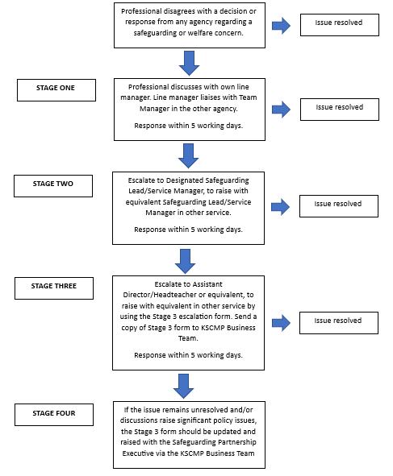

The KSCMP Executive members are: KCC Corporate Director for Children’s Services, Kent Police Assistant Chief Constable for Crime, NHS Kent and Medway Chief Nurse

